Practical Exercise 3

Question 1
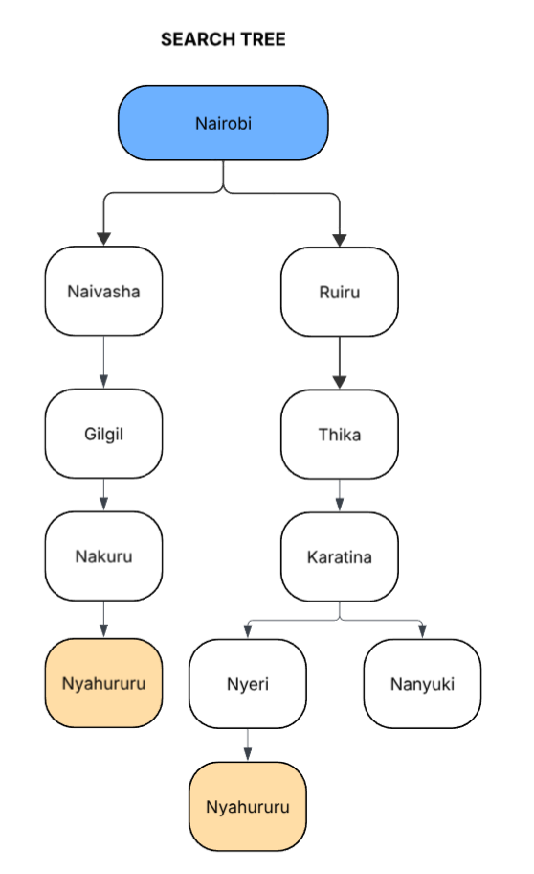
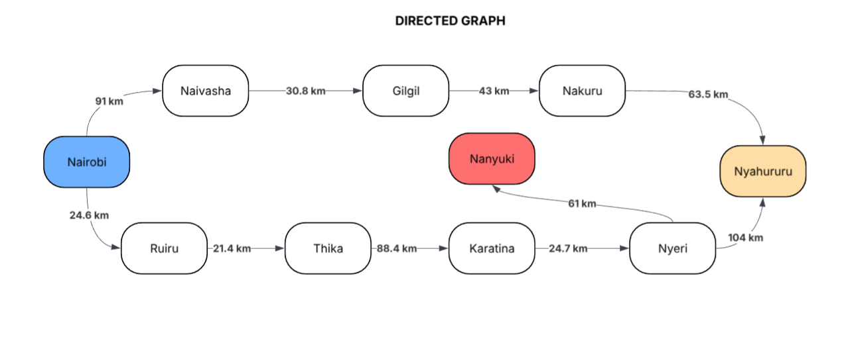

Question 2
- BFS (Breadth First Search)
Strategy: The agent explores the graph layer by layer. It visits all neighboring towns at the current depth level before moving deeper to the next level. It applies a FIFO (First-In, First-Out) Queue.
Step 1 (Level 0): Start at Nairobi.
Step 2 (Level 1): The agent expands Nairobi and discovers two neighbors: Naivasha and Ruiru. It then adds them to the back of the queue.
Step 3 (Level 2):
  - It visits Naivasha first (since it is at the front of the queue). It sees Gilgil. (then adds it to the back of the queue)
  - It visits Ruiru next. It sees Thika.
  - Current Queue: [Gilgil, Thika]
Step 4 (Level 3):
(The same queue process is applied)
  - It visits Gilgil. It sees Nakuru. (then it is added to the queue)
  - It visits Thika. It sees Karatina.
  - Current Queue: [Nakuru, Karatina]
Step 5 (Level 4):
  - It visits Nakuru. From here, it sees Nyahururu.
Goal Test: Since Nyahururu is the destination, the search stops successfully.

Final Path Found: Nairobi → Naivasha → Gilgil → Nakuru → Nyahururu.

- DFS (Depth-First Search)
Strategy: The agent explores one branch as deep as possible before backtracking. If it hits a dead end or the goal, only then does it consider alternative branches. It uses a LIFO (Last-In, First-Out) Stack.
Step 1: Start at Nairobi.
Step 2: The agent chooses the first available path, Naivasha.
Step 3: From Naivasha, it moves directly to Gilgil.
Step 4: From Gilgil, it moves directly to Nakuru.
Step 5: From Nakuru, it moves directly to Nyahururu.
Goal Test: The agent finds the goal immediately without ever needing to backtrack.

Sidenote: If the agent had picked the Ruiru branch first, it would have gone all the way to Nanyuki (dead end), backtracked to Karatina, gone to Nyeri, and then found Nyahururu.
Final Path Found: Nairobi → Naivasha → Gilgil → Nakuru → Nyahururu.

- UCS (Uniform Cost Search)
Strategy: The agent explores the path with the lowest cumulative cost. It constantly re-evaluates which node in the frontier is the cheapest to reach from the start.
Step 1 (Start):
  - Frontier: Nairobi (0 km)
Step 2 (Expand Nairobi):
  - Path A: Nairobi →Naivasha (91 km)
  - Path B: Nairobi →Ruiru (24.6 km)
Decision: Ruiru is cheaper (24.6 < 91). The agent explores Ruiru first.
Step 3 (Expand Ruiru):
  - Ruiru →Thika (24.6 + 21.4 = 46.0km)
Comparison: The cost to reach Thika (46) is still cheaper than reaching Naivasha (91). The agent continues on this path.
Step 4 (Expand Thika):
  - Thika → Karatina (46.0 + 88.4 = 134.4 km)
Comparison: Now, the cost to reach Karatina (134.4) is higher than the pending path to Naivasha (91).
Switch: The agent pauses the Karatina route and switches back to Naivasha.
Step 5 (Expand Naivasha):
  - Naivasha → Gilgil (91 + 30.8 = 121.8 km)
Comparison: Gilgil (121.8) is cheaper than Karatina (134.4). Continue on this path.
Step 6 (Expand Gilgil):
  - Gilgil → Nakuru (121.8 + 43 = 164.8 km)
Comparison: Nakuru (164.8) is now more expensive than Karatina (134.4).
Switch: The agent switches back to the Karatina node.
Step 7 (Expand Karatina):
  - Karatina → Nyeri (134.4 + 24.7 = 159.1 km)
  - Karatina → Nanyuki (134.4 + 61 195.4 km)
Comparison: The path to Nyeri (159.1) is cheaper than Nakuru (164.8). The agent checks Nyeri.
Step 8 (Expand Nyeri):
  - Nyeri → Nyahururu (159.1 + 104 = 263.1 km)
Comparison: This total path cost is very high. The pending path to Nakuru is only (164.8).
Switch: The agent switches back to Nakuru.
Step 9 (Expand Nakuru):
  - Nakuru → Nyahururu (164.8 + 63.5 = 228.3 km)

Goal Reached: The agent compares the two paths to the goal. The Nakuru route (228.3 km) is cheaper than the Nyeri route (263.1 km).
Final Path Selected: Nairobi → Naivasha → Gilgil → Nakuru → Nyahururu.
Total Cost: 228.3 km.

